**ONLINE BOOK SELLING MANAGEMENT SYSTEM**

**CASE STUDY: CHARISMA BOOKSTORE.**

**BY**

**UWAMAHORO JACKY**

**IT & ARCHITECTURE**

[**Bachelor Business of Information Technology**](http://www.jkuat.ac.ke/schools/SODeL/bachelor-of-business-information-technology-bbit/)

**BBIT/14/03/0786**

**Email: ojilo40@gmail.com**

**October 2017**

**CHAPTER FOUR**

**4.0. SYSTEM ANALYSIS, DESIGN AND IMPLEMENTATION**

**4.0. System study**

**4.1. Introduction to the study**

In this chapter we are going to analyze deeply this system, design and implementation of this online books selling system and in this chapter provided the output of the system and how it work and the way it will solve different problems.

**4.2. The System Study**

This study describe in detail the process that I pass through in order to carry out this system and to achieve this level before I started this new system which is called Online book selling System which is in charge of improving performance and efficiency in handling book sales via internet and provide an easy way buying and selling books by using technology.

**4.2.1. Weakness observed in the current system**

Different libraries are managing all books, orders, and customers with the help of filing systems. The buyers used to go and pay for the book of his/her interest by face to face manner. This delay time because it takes long journey to the customers to reach where they shop books. They are not using any computerized system to manage the business.

**4.3. System Analysis**

Systems analysis is a problem solving technique that decomposes a system into its component pieces for the purpose of the studying how well those component parts work and interact to accomplish their purpose.

This Systems analysis is a process of collecting factual data, understand the processes involved, identifying problems and recommending feasible suggestions for improving the system functioning. This involves studying the business processes, gathering operational data, understand the information flow, finding out bottlenecks and evolving solutions for overcoming the weaknesses of the system so as to achieve the organizational goals. System Analysis also includes subdividing of complex process involving the entire system, identification of data store and manual processes.

**4.3.1. User Requirement of the proposed system**

The user visits online book selling system and register user is customers. Only the seller manages his/her account and payment method. So in this part, specific functions are described as below:

* Login and logout
* Register
* Handle payment method
* View historical payment
* Update account information.

**4.3.2. Functional Requirement of the proposed system**

* System must be able to add/modify customer.
* Customer must be able to view his/her personal details only.
* Customer must be able to view his/her payment history.
* Each customer must be able to view payment status.
* System must alert the customer for new charge to be made.
* System manager must be able to view orders of a customer.
* The system must guarantee secure access to the stored data, managing the permissions according to the user profile.
* The system must support easy addition of functionalities and enhancements

**4.3.3. Non functional requirements**

System shall automatically make backups after every 4 months. This can be tuned according to company needs too. System connectivity with internet shall be ensured through backup line. The safety of the system information shall be insured by means of firewall. Other non functional requirements of store management system are:

* **Usability:** The system is easy to use and easy to learn.
* **Reliability:** the extent to which it works as and when needed.
* **Appearance:** It **is good** looking, pleasant and even attractive to its users.
* **Availability:** It is available to use 24hours a day.
* **Security:** accessible and usable only in authorized ways by authorized users because each user has his/her own account which is protected by a password.
* **Installation:** ease, speed and reliability of installing a product, system or software for use because the systems specifications for installation are easy to obtain.
* **Distribution:** as it is easy to install it and compatible to different systems and products therefore in its distribution it is easy.
* **Database:** structure, efficiency and integrity of stored data lies in the hands of the administrator as His/her duties to update data or even delete them.

**4.3.4. System Requirement**

System requirements are a structured document setting out detailed descriptions of the system services (Ian Somerville, 2004).

**4.3.5 Requirement specification**

## 4.3.5.1. Hardware specifications

Computer: HP, Del, Mac, Techno...

Processor: Intel(R) Core(TM) i7-3630QM CPU @2.40GHZ, etc

RAM: At least 2GB

##### **4.3.5.2 Software specifications**

**Client-side specifications:**

Operating system: Windows 7 and above

**Server-side specifications:**

Operating System: Windows XP, Windows server 2003 and above

Local server: Xamp server for Windows

**4.4. Systems Design**

**4.4.1. Overview**

The web system was built keeping in mind the simplicity and performance of the system. Because the system was built for online business and was supposed to be a medium to carry out all sales tasks between the buyer and the seller so it was very important to make the system user friendly. Therefore during the design phase the emphasis was to make this system more users friendly and more efficient. So that all business tasks can be done easily and error free

**4.4.2. Architectural Design**

Architecture is the fundamental organization of a system, embodied in its components, their relationships to each other and the environment, and the principles governing its design and evolution.

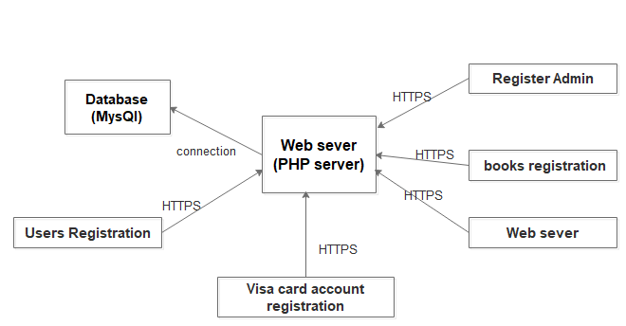

**Figure 4.1. : Architectural design**

**Source: My own design**

**4.4.3.** **Data Flow Diagram and Context Diagram**

Data Flow Diagrams show the flow of data from external entities into the system, and from one process to another within the system. There are four symbols for drawing a DFD:

1. Rectangles representing external entities, which are sources or destinations of data.

2. Ellipses representing processes, which take data as input, validate and process it and output it.

3. Arrows representing the data flows, which can either, be electronic data or physical items.

4. Open-ended rectangles or a Disk symbol representing data stores, including electronic stores such as databases or XML files and physical stores such as filing cabinets or stacks of paper.

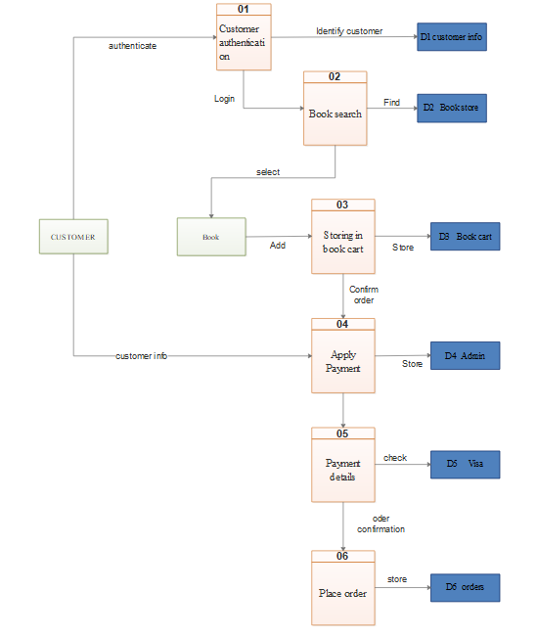

**Figure 4.2. : DFD design**

**Source: My own design**

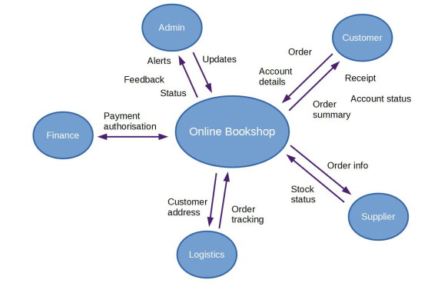

Figure 4.3: Context Diagram

**Source:** My own Design

**4.4.4.** **Database Design**

**Database design** is the process of producing a detailed data model of a database. This data model contains all the needed logical and physical design choices and physical storage parameters needed to generate a design in a data definition language, which can then be used to create a database. A fully attributed data model contains detailed attributes for each entity.

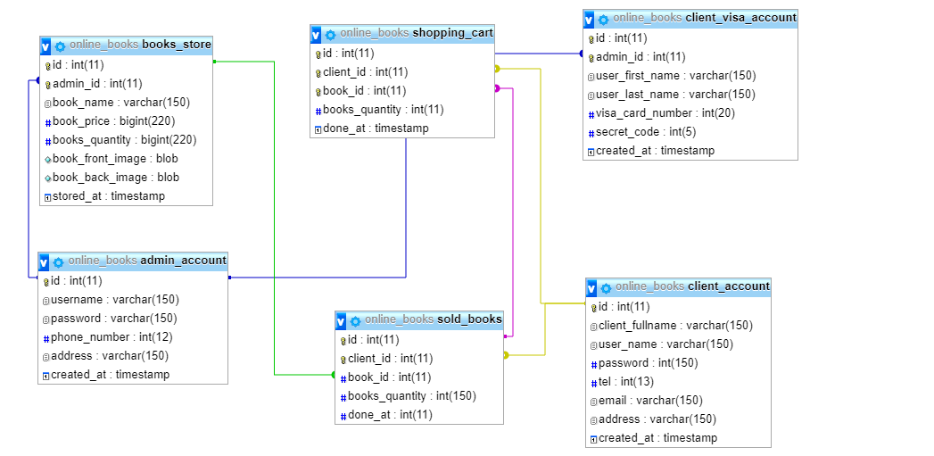

**Figure 4.4. : Database design**

**Source: My own design**

**4.5. System implementation**

System implementation is an important phase in software development life cycle. Web based online books selling system is implemented on Windows operating systems. In system implementation stage, the newly developed system is delivered to the users, organization after proper and adequate testing. System implementation encompasses series of stages and each of these stages is essential to the successful implementation of any system.

Implementation: The implementation stage is carried out in the following aspects:

1. defining how the information system should be built (i.e., physical system design),
2. ensuring that the information system is operational and used,
3. Ensuring that the information system meets quality standard (i.e., quality assurance).

**4.5.1. Screen shots of a running program**



**Figure 4.5:** Home page

This is screen appears anytime end user visits the system at the first time , on navigation menu of this page there is an horizontal list of pages which list different books categories, home page provides the search box what can be used for different books search , shows also the list of most popular books

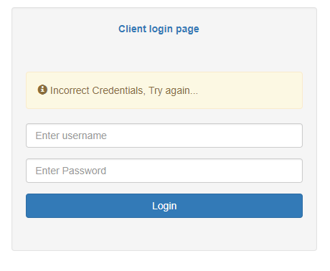

**Figure 4.6:** client login page

On this page user can’t not login when his/her credentials are incorrect or with empty fields, means that in order to buy any book on the system a user must be having his/her shopping account.

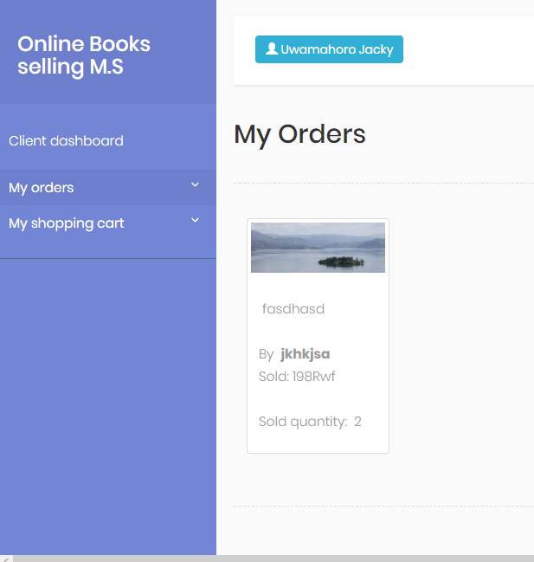

**Figure 4.7: client dashboard**

Client dashboard helps a user to find an track the details of what he bought or what he added to his/her shopping cart.

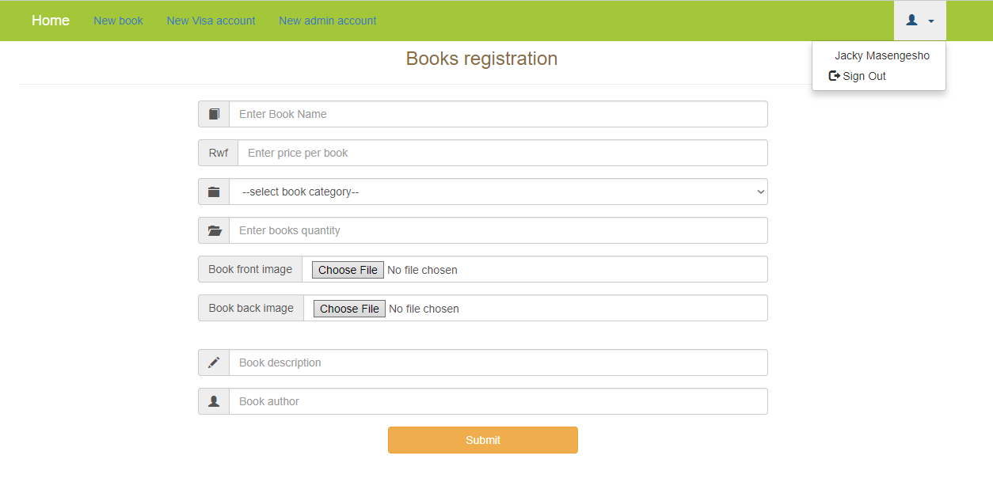

**Figure 4.8: Admin dashboard**

Likewise to the client admin must have a login account in order to get in his/her dashboard ,but for admin his dashboard will be used to register other system administrators, publishing new books online ,update and delete privileges, create clients visa accounts and more.

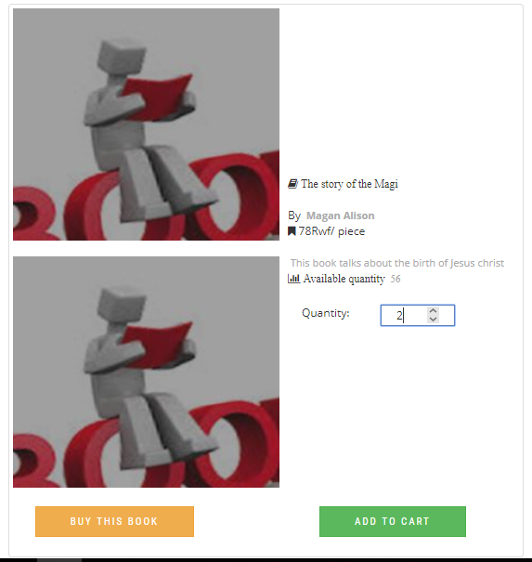

**Figure 4.9: Buy and shopping cart process**

With this page a user specifies the quantity of books he/she needs the he process by choice.

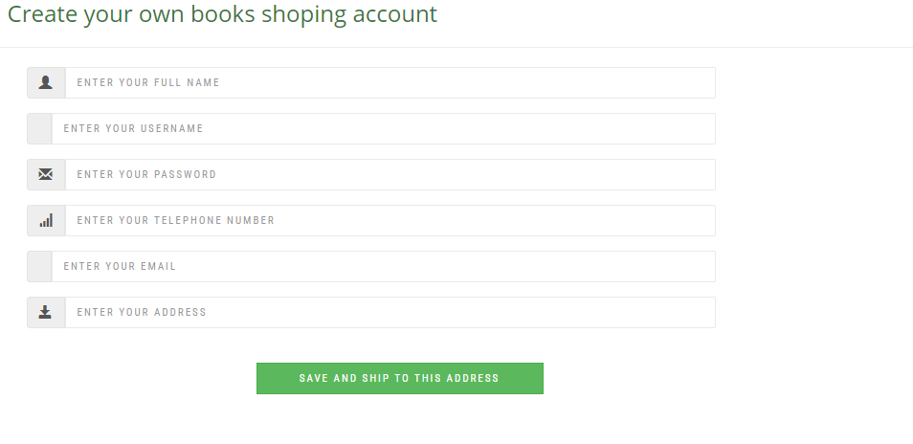

**Figure 4.10: Unregistered buyer interface**

When a user is not registered next step will be to fill his shipping address

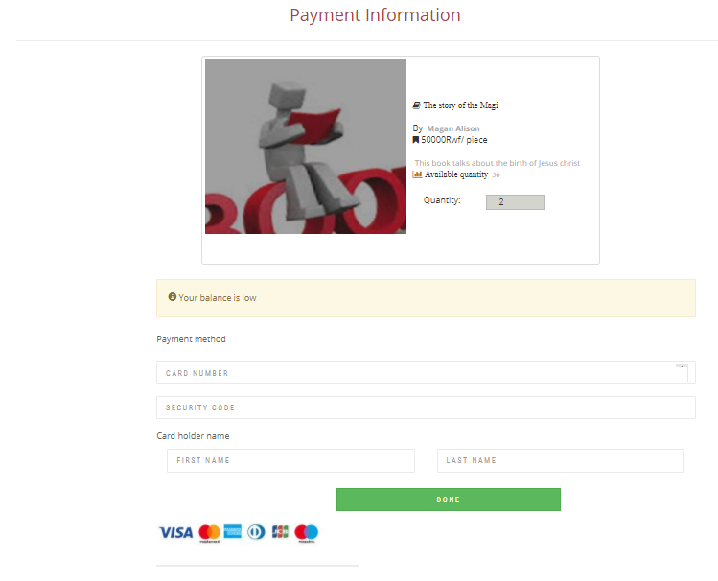

**Figure 4.11: The last book shopping page**

On this page a client is requested to fill his visa card number and secret code

**4.6. System testing**

For the application or website to be deployed it has to be tested .hence test cases will be written to test this application. They are many types of test to be carried out on a web application from performance, functionality, database loading time, response time, server time handling, user’s actions and many others. Including

* Load the website on all browsers
* Registration on the website using all browsers and making sure a new member gets registration feedback email
* Change the query string to a digit if it’s a string or to string if it’s a number
* Inject JavaScript code on the feedback page
* Search for books
* Do the categories reflect what type of books the user wants to buy?
* Can the visitor easily find a book on the website?

**4.7. Validations**

I made some pages to inherit from the Base page. This makes it easy to add functionality to all pages that inherit from this page. The pages can the user that method defined in the Base page.

I validate all input from the user before saving it into the database .I use the RequiredFieldValidator controls, the RangeFieldValidator , DatatypeValidator, and the RegularExpressionValidator controls for emails and number for books to make sure that input sources are right and the types are right. I use parameters when it comes to input into the database hence preventing SQL injections to go through .I also use LINQ to SQL which by itself naturally prevents such attacks because all the data is parameterized before sending it to the database. I validate query string types before using them. This was easily done using regular expressions for example to check is it’s a decimal or string before using the query to generate any data from the database.

* Search for books ->PASSED
* Is it easy to move between pages on the website? ->PASSED
* Add all the books to the shopping cart .Get the total before and total when checking out. ->PASSED
* Adding, deleting and updating items the user uploaded ->PASSED
* Clicking buttons haphazardly on the website and seeing what happens ->PASSED

**CHAPTER FIVE**

**5.0. DISCUSSION, CONCLUSIONS AND RECOMMENDATIONS**

**5.1. Discussion**

A good shopping cart design must be accompanied with user- friendly shopping cart application logic. It should be convenient for the customer to view the contents of their cart and to be able to remove or add items to their cart. The shopping cart application described in this project provides a number of features that are designed to make the customer more comfortable. This project helps in understanding the creation of an interactive web page and the technologies used to implement it. The design of the project which includes Data Model and Process Model illustrate show the database is built with different tables, how the data is accessed and processed from the tables. The building of the project has given me a precise knowledge about how Java Script is used to develop a website, how it connects to the database to access the data and how the data and web pages are modified to provide the user with a shopping cart application.

**5.2. Conclusion**

The Internet has become a major resource in modern business, thus electronic shopping has gained significance not only from the entrepreneur’s but also from the customer’s point of view. For the entrepreneur, electronic shopping generates new business opportunities and for the customer, it makes comparative shopping possible. As per a survey, most consumers of online stores are impulsive and usually make a decision to stay on a site within the first few seconds. “Website design is like a shop interior. If the shop looks poor or like hundreds of other shops the customer is most likely to skip to the other site”. Hence we have designed the project to provide the user with easy navigation, retrieval of data and necessary feedback as much as possible.MySQL was used as back- end database since it is one of the most popular open source databases, and it provides fast data access, easy installation and simplicity.

**5.3. Recommendation**

The system is not configured for multi - users at this time. The concept of transaction can be used to achieve this.

The Website is not accessible to everyone. It can be deployed on a web server so that everybody who is connected to the Internet can use it.

The Administrator of the web site can be given more functionality, like looking at a specific customer’s profile, the books that have to be reordered, etc.

Multiple Shopping carts can be allowed

**REFERENCES**

Jeffrey l. Whitten, Lonnie D. Bentley, Kevin C. Dittman title:*Systems analysis and Design Methods 6th Edition* 2004 pp12)

Brian k. Williams, Stacey C. Sawyer, and Sarah E. Hutchinson title: *Using Information Technology 3rd* edition (1999) pp460-461

Acker, Ally (1991), Web Information systems, Academic press, UK.

Sweeting,(1969), Traditional Theater booking Systems,Arcadia Publishing, US

Booch G., Rumbaugh J & Jacobson I.(1998), *The Unified Modeling Language User Guide(1st ed.),* Boston Addison Wesley,US.

ErickonVonk,(1998) Netscape communicator and the "World Wide Web", Michigan Technology University,US.

Fitz G. (1987), *Fundamentals of Systems, 3rd Edition,* Prentice Hall Publishers,US.

William Lynd(1885), *An Entity Relational Approach,* The Benjamin Cummings publishing company,US.

# https://www.mitre.org/publications/systems-engineering-guide/se-lifecycle-building-blocks/system-architecture [Accessed:21st November 2017]

<https://developer.mozilla.org/en-US/docs/Web/CSS> **[Accessed:25 November** **2017]**

[https://developer.mozilla.org/en-US/docs/Web/JavaScript](https://developer.mozilla.org/en-US/docs/Web/JavaScript%20)  **[Accessed: 15 Sept 2017]**

<https://dev.mysql.com/doc/refman/5.7/en/what-is-mysql.html> **[Accessed:25 November** **2017]**

<https://www.1keydata.com/datawarehousing/physical-data-model.html> **[Accessed: 2 December 2017]**

<https://www.tutorialcup.com/dbms/data-dictionary.htm> **[Accessed: 2 December 2017]**

<http://www.codementor.io/codeforgeek/build-website-from-scratch-using-expressjs-and-bootstrap-du107sby7> **[Accessed:18 December 2017]**

<https://www.tutorialrepublic.com/twitter-bootstrap-tutorial/bootstrap-get-started.php> **[Accessed:12 January 2018]**

**APPENDICES**

1. **Sample Codes used**

The following sniped code used for database connection in all pages

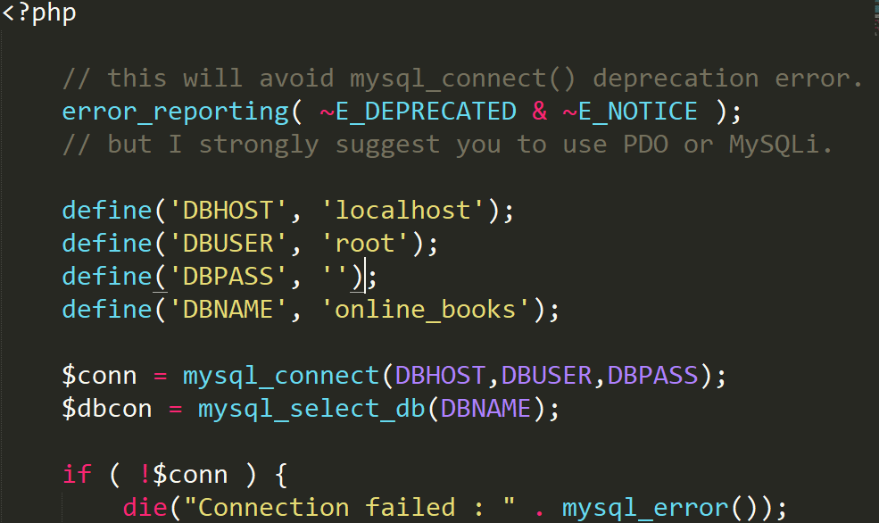

**Hope page sample code:**

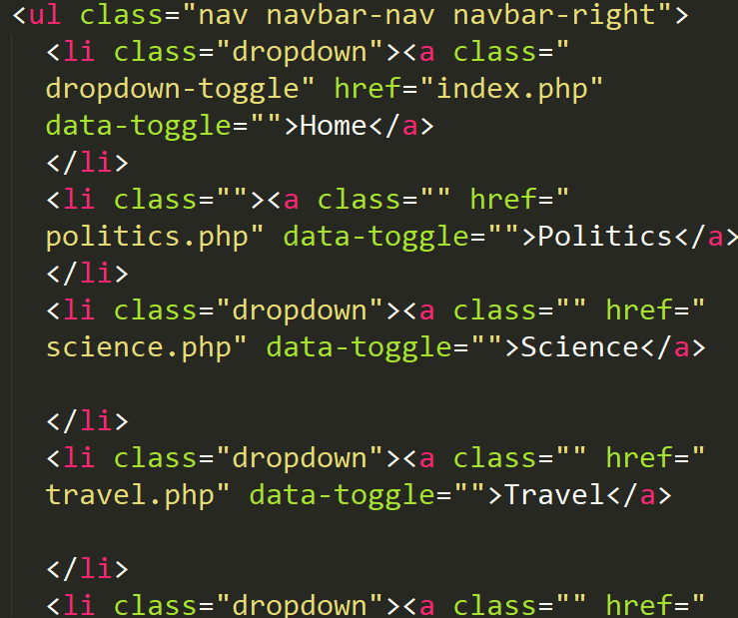

1. **Budget**

1. Transport: 50000 Rwf

2. Internet Bundles: 10000 Rwf

3. Lunch: 50000 Rwf

4. Calls fee: 30000 Rwf

Total: 140000 Rwf

1. **Work plan**

The first 3 chapters which have been presented as project proposal took one month to be finished. After that the software part of the project and 2 chapters took more than 2 months, which leads to the conclusion that the project took 3 months to be finished. All this time was spent coding and collecting Data as well as doing research through resources as books or internet PDF documents or websites.